**DOCUMENTATION FOR SCENARIO-2:**

* **What is Scenario-2?**
* **Alice is a user of the WINGS WORKFLOW SYSTEM.**
* **Alice wanted to carry out some sorting of text files.**
* **She created a workflow with a sorting algorithm named Bubble-sort.**
* **She created this new Concrete Component Bubble-Sort and kept it under the Abstract Component SORT.**
* **The SORT Abstract Component has 1 Input, 1 Output.**
* **The new Bubble-Sort concrete Component has 1 Input, 1 Output and 1 parameter.**
* **When the Workflow is published the WINGS Component Catalog exports this scenario as:**

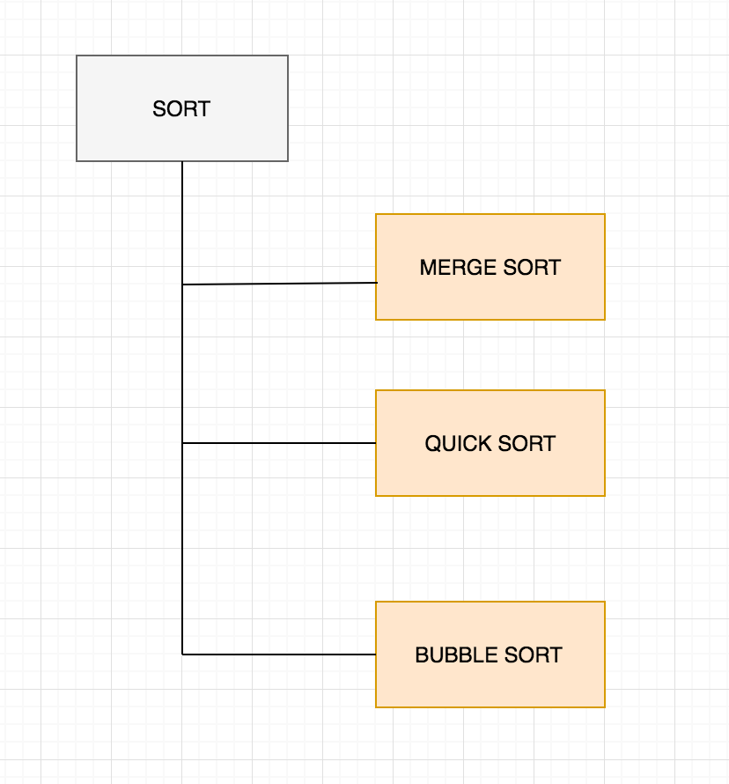

* **Bubble Sort’s concrete component is this:**

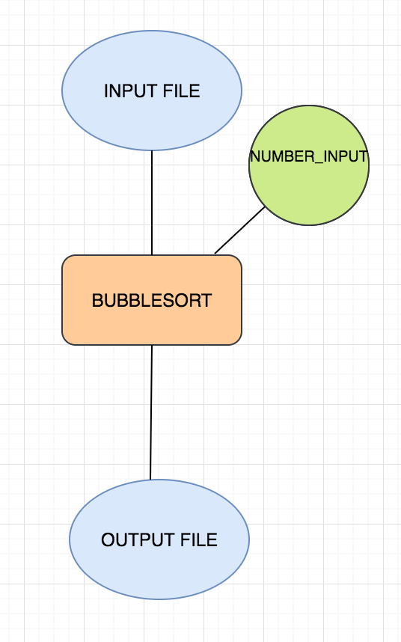

* **The PROBLEM is:**
* **Well, the component catalog currently has Mergesort, QuickSort and the newly added BubbleSort under the same abstract component SORT which is WRONG.**
* **SOLUTION:**
* **We are creating a new TAXONOMY HIERARCHY MODEL (THM) for exporting these changes that will help maintaining a good consistency of components and versioning.**
* **We had export SORT_V1 and QuickSort and MergeSort under it along with their canonical instances.**

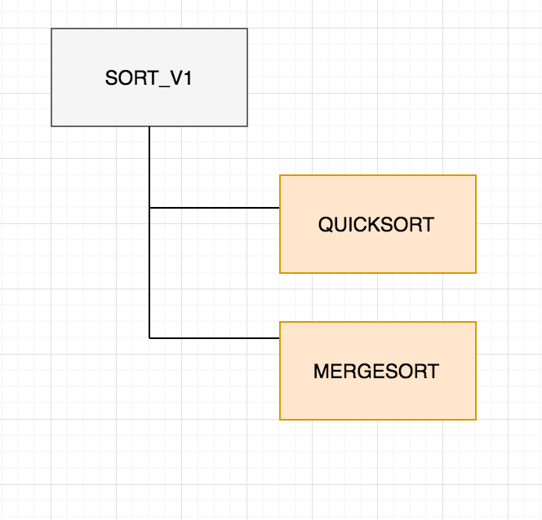

* **We will now export SORT_V2 with BubbleSort under it along with the canonical instance.**

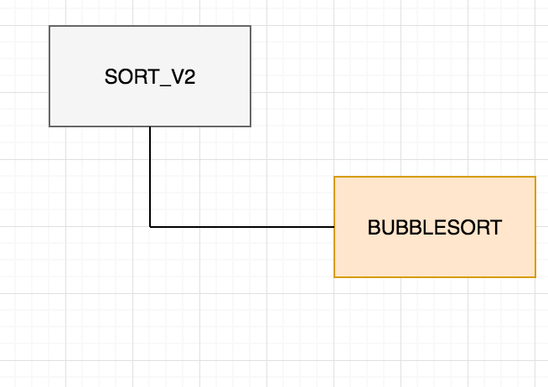

* **Further we connect the canonical instances of SORT_V2 to SORT_V1 and say that it is a prov:is revision of SORT_V1.**

